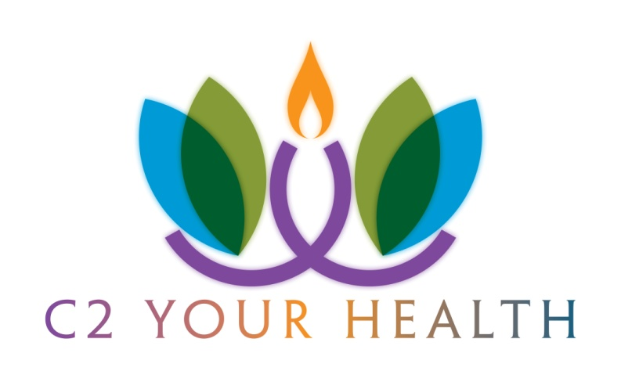
Groups Offered
8720 Forest Hill Avenue, Richmond, VA 23235

Mindfulness for Women:
A group for women who experience depression and/or anxiety and want to learn new and innovative ways to slow down, find balance, and develop skills to help master stress and worries. Based on Mindfulness Stress Reduction techniques. Led by Erin Hawkins, LCSW. Group meets quarterly on Mondays from 7-8:15pm.

Coping Skills Using DBT: High School Girls
A collaborative process group for High School girls who want to learn more positive ways to cope with overwhelming emotions. Targeting girls who engage in self-damaging behaviors, struggle with depression, anxiety, and/or eating disorders. Uses DBT and CBT skills. HS girls meet with Christine Lamps, LCSW and Christopher Lamps, MD once per week. Parents meet once per month. Group meets on Wednesdays from 6:30-7:45pm. Cost is $40.
A second DBT group is facilitated by Carrie Kerr, LCSW and Lynda Leslie, LCSW and meets once per week. Group meets on Tuesdays from 6:30-7:45pm.

Middle School Girls Coping Skills Group:
CBT (Cognitive Behavioral Therapy), DBT and Mindfulness skills for middle school girls who struggle with anxiety, depression, peer difficulties, and/or difficulty regulating emotions. Learn specific skills to stop avoidance patterns and reduce self-judgment. MS girls meet with Erin Hawkins, LCSW once per week for 8-10 weeks.

To register or for more information on any of these offerings, please contact (804)325-1669 or visit www.C2YourHealthPC.com.
Groups Offered
8720 Forest Hill Avenue, Richmond, VA 23235
ACT Teen Relapse Prevention Group:
Acceptance and Commitment Therapy is an evidence-based treatment for eating disorders that focuses on acceptance, values and committed action. These are essential skills in the recovery journey. This group is designed for teens who are in the recovery phase of an eating disorder. The group is facilitated by Christine Lamps, LCSW, CEDS. Group meets every other week at 5:30pm. Cost is $40.
Adult ED Relapse Prevention Group:
A therapist facilitated group meets twice per month to address the ongoing but advanced issues in recovery from an eating disorder. The group targets adult males and females. Topics include relationships with peers, family and intimates; school and job issues; exercise; communication with treatment team; balancing recovery with life responsibilities; and moving towards values. Meets every other week at 6:30pm. Cost is $25.
Body Image and Self-Esteem Group
A group for girls and young women who desire a healthier relationship with their bodies. Targeting adolescents and young adults who are active in their recovery efforts and who have struggled with disordered eating. Group incorporates Body Positive material as well as Art Therapy. Group meets every other week at 5:30pm and is facilitated by Christine Lamps, LCSW, CEDS. Cost is $40.

Yoga for Eating Disorders
Please join Masters Level Counseling Intern and RYT 500 Yoga Teacher Izzy Shurte for this weekly therapeutic yoga group to explore relationship to your body through yoga. Learn and practice new ways to contact and regulate emotion including mindfulness, self compassion and loving kindness. Time will be provided each week to process experience in group format. Space limited to 10 participants. Group meets on Fridays at 6pm. Cost is $100 for 5 groups.

To register or for more information on any of these offerings, please contact (804)325-1669 or visit www.C2YourHealthPC.com.

